# Database Exam (November 2015) – Photography

Your exam consists of several parts, explained below. You may work independently on each exam part. Submit your solutions in the automated judge system: <https://judge.softuni.bg/Contests/136/Databases-Retake-Exam-16-November-2015> .

## Part I – Preliminary Setup

The automated judge system will expect from you to submit **only the output of your queries, and not your actual queries**. The output should be **comma delimited (without spaces** in the delimiter), including column **headers not surrounded by quotes** and **without** the **rows affected** by the query.

A sample output could be:

|  |
| --- |
| Username,First Name,Registered On,Email  Joiner,Adriano,2014-07-06,Joiner@gmail.com  JonSkeet,Jon,2013-02-03,JonSkeet@yahoo.com  HonzaBrabec,Honza,2012-12-08,HonzaBrabec@brabec.com  RaviKumar,Ravi,2012-08-22,kumar@abv.bg |

To achieve this:

1. Open **SQL Server Management Studio**
2. Click on **Tools *-> Options***

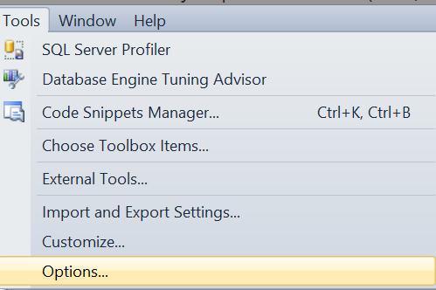

1. Click on **Query Results -> SQL Server -> Results to Text**
2. Change the **dropdown** in the upper right corner to “**Comma delimited**”
3. Ensure the **checkbox** **“Include column headers in the result set”** is **checked**

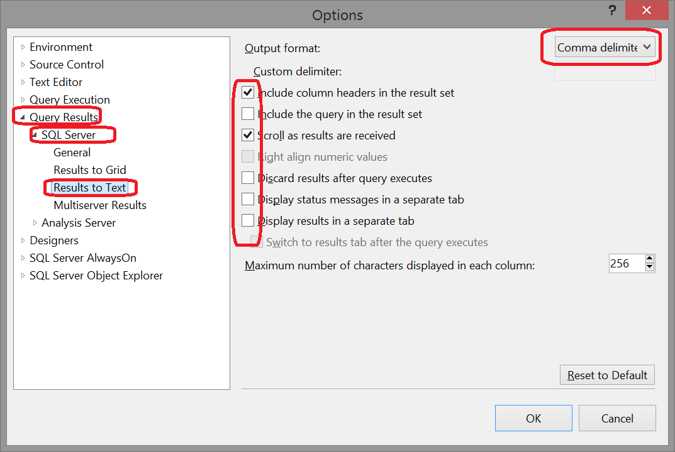

1. Change the **text box “Maximum number of characters displayed in each column”** to **8192**

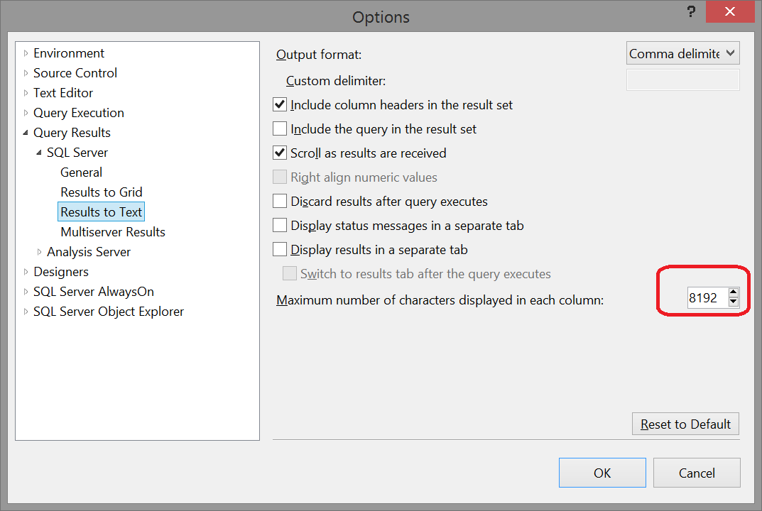

1. Click **OK**
2. Restart **SQL Server Management Studio**
3. The standard output is still Grid. You can use it for easier check if the output is like in the grid in this document, but **in order to submit comma delimited text you need to switch to Results to Text. Press CTRL + T** or click the icon from the screenshot below **before executing your query**



1. You can **optionally** switch the default execution to be **Results to text, if you don’t want to click CTRL + T each time** before executing a query for evaluation

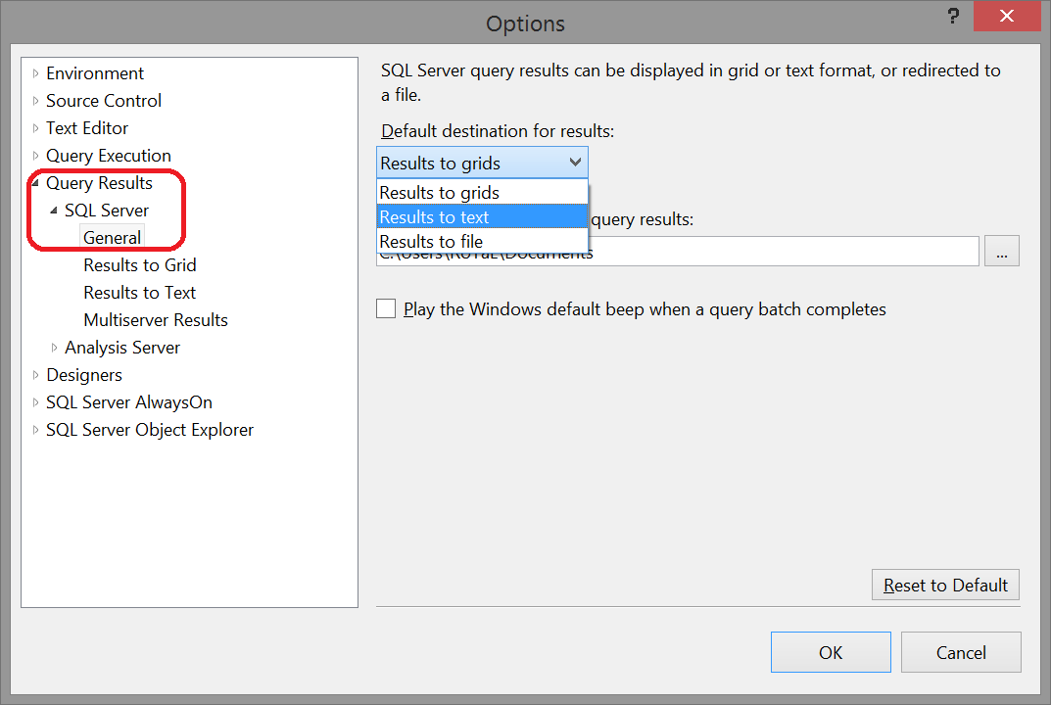

* 1. Repeat steps **7. and 8.**

## Part II – SQL Queries

You are given an **MS SQL Server database "Photography"** holding users, photographs, albums, cameras, categories, manufacturers, and lenses, available as SQL script. Your task is to write SQL queries for displaying data from the given database. In all problems, please **name the columns exactly like in the sample tables below**.

### Problem 1: Album’s Name and Description

Write a query that selects the **name** and **description** of all albums. If there is no description, display “**No description**”. Sort the results by **name** in alphabetical order. Name the columns **exactly** like below.

|  |
| --- |
| Name,Description  Digital Kids Conference - 1 Nov 2014,No description  Mobile,Mobile uploads  … |

2 points

### Problem 2: Photographs and Albums

Write a query that selects the **names** of all **photographs** along with the **titles** of the **album** they belong to. Sort the results by album name in **ascending** order and then by photograph name in **descending.**

|  |
| --- |
| Title,Name  Tilma Lek,Mobile  Sitting on a tree...,Mobile  Best Photo Ever,Mobile  … |

3 points

### Problem 3: Photographs with Category and Author

Write a query that selects the **title, link, description, category and author** of all **photographs.** Display **only** the photographs that have description. Sort the results by title in **ascending** order. Name the columns **exactly** like below.

|  |
| --- |
| Title,Link,Description,CategoryName,Author  Best Photo Ever,http://photo-forum.net/i/1920515,Period !,Portrait,Alexandra Svilarova  Dog,http://photo-forum.net/i/1920281,Aint he a fluffy bag?,Street,Daniel Bocksteger  … |

3 points

### Problem 4: Users Born in January

Write a query that finds all users born in January. Select the **username**, **fullname**, **birthdate,** and **photo** **title** of the found users. If the user has no photo, display “**No photos**”. Sort the results by fullname in **ascending** order. Name the columns **exactly** as below.

|  |
| --- |
| Username,FullName,BirthDate,Photo  ben,Ben Ford,1985-01-07 00:00:00.000,Time of poets  casper,Casoer Beyer,1983-01-31 00:00:00.000,No photos  … |

3 points

### Problem 5: Photographs with Equipment

Write a query that selects the **titles** of all photographs from the database, along with the **models** of the **camera** and **lenses** they are captured with. Sort the results by title in **ascending** order. Name the columns **exactly** like below.

|  |
| --- |
| Title,CameraModel,LensModel  Angel eyes,EOS 760D,EF 15mm f/2.8 Fisheye  Best Photo Ever,EOS 760D,EF 15mm f/2.8 Fisheye  … |

4 points

### Problem 6: *Most Expensive Photos

Write a query that selects from each category the photo taken with the most expensive camera. Take the **photo** **title, category name, camera model, manufacturer’s name, camera megapixels and price.** Sort the results by price in descending order and by photo title in ascending. Name the **columns** exactly as below.

In case there are multiple photos taken with the same camera per category, display all.

|  |
| --- |
| Title,Category Name,Model,Manufacturer Name,Megapixels,Price  Angel eyes,Portrait,EOS 760D,Canon,24,1298.00  Best Photo Ever,Portrait,EOS 760D,Canon,24,1298.00  … |

7 points

### Problem 7: Price Larger Than Average

Write a query that selects the manufacturer’s **name,** camera **model** and **price** of all cameras whose price is larger than the average. Sort the results by **price** in **descending** order and by **model** in **ascending**.

|  |
| --- |
| Name,Model,Price  Pentax,645Z,8024.00  Nikon,D810,4697.00  Canon,5DS,3899.00  … |

5 points

### Problem 8: Total Price of Lenses

Write a query that selects the **total price** of lenses **per manufacturer**. Additionally, select the manufacturer’s name. Sort the results by **name** alphabetically. Name the columns exactly as below.

|  |
| --- |
| Name,Total Price  Canon,5746.00  Nikon,13080.00  … |

5 points

### Problem 9: Users with Old Cameras

Write a query that finds user’s whose cameras are **older** than 2015. Select the **fullname, manufacturer, camera model** and **megapixels**. Sort the columns by **fullname** alphabetically. Name the columns **exactly** as below.

|  |
| --- |
| FullName,Manufacturer,Camera Model,Megapixels  Adriano Abatangelo,Canon,PowerShot SX700 HS,12  Alexandra Svilarova,Fujifilm,XQ1,14  … |

3 points

### Problem 10: Lenses per Type

Write a query that selects the count of lenses per type. Sort the results by the **count** in descending order and by **type** alphabetically. Name the columns **exactly** as below.

|  |
| --- |
| Type,Count  Telephoto zoom lens,5  Wideangle fisheye prime lens,5  … |

4 points

### Problem 11: Sort Users

Write a query that sorts the users by the **combined** length of their **username** and **fullname** in **ascending** order**.** If two users have the same combined length, order them by birthdate in **descending** order. Name the columns exactly as below.

|  |
| --- |
| Username,FullName  ben,Ben Ford  ziba,Ziba Leah  buch,Arpan Buch  Qwerty,Tony Quig  … |

3 points

### Problem 12: Manufacturers without Products

Write a query that finds all manufacturers that have no **cameras** and no **lenses**. Take the manufacturer’s name. Order the results **alphabetically**.

|  |
| --- |
| Name  Agfa  Casio  … |

4 points

**Part III – Changes in the Database**

You are given an **MS SQL Server database "Photography"** holding users, photographs, albums, cameras, categories, manufacturers, and lenses, available as SQL script. Your task is to modify the database schema and data and write SQL queries for displaying data from the database.

In all problems, please **name the columns exactly like in the sample tables below**.

**Important: Tasks are dependent. The manipulation in Task 13 is required for the output of Task 14**

### Problem 13: Cameras rise!

The cameras rose. The rising logic is the following. Camera’s price is raised by

the average price of cameras of its manufacturer

multiplied by

a percent equal to the manufactu**r**er’**s** name length.

After this manipulation print the three most expensive cameras’ Model, Price and ManufacturerId per manufacturer, ordered by ManufacturerId then by Price then by Model.

|  |
| --- |
| Model,Price,ManufacturerId  645Z,8***.0***,4  K-5 II,1***.0***,4  K-3,1***.0***,4  5DS,3***.4***,5  … |

9 points

### Problem 14: Most cameras for given cash

You are given 54187 cash. Write a query that extract how many and which cameras one can buy with that cash, respecting the fact the one needs to buy as much as possible cameras. If two cameras have the same price, higher precedence takes that one with bigger Id. Print the cameras ordered by Year descending, then by ManufacturerId descending, then Id ascending.

|  |
| --- |
| Id,ManufacturerId,Model,Year,Price,Megapixels  78,19,Cyber-shot DSC-RX10 II,2015,1357.77,22  77,19,Cyber-shot DSC-RX100 IV,2015,1007.77,20  … |

12 points

## Part IV – Stored Procedures / Functions / Triggers

Your task is to write some stored procedures, views and other server-side database objects and write some SQL queries for displaying data from the database.

### Problem 15: Stored procedure for creating equipment

Write a function usp_CreateEquipment(modelName) that find camera(s) by given model name, then find lenses with the same manufacturer id and creates an equipment record by this pair.

If the camera’s manufacturer is not present for any lens

Or

there is already a pair with that camerId<->lensId,

then try to find lenses with the next manufacturer id

until finding lens(еs)

or

it becomes impossible to find any.

If it’s impossible, should not add an equipment pair (because of the lens absence or because all possible pairs exists).

If the function finds lenses from a manufacturer id that can be added – adds them and then exits, without going to the next manufacturer id. Jumping on the next manufacturer id is applied only if none of the lenses are applicable, or none are present.

Example:

|  |  |  |  |  |  |  |  |  |  |  |  |  |  |  |  |  |  |  |  |  |  |  |  |  |  |  |  |
| --- | --- | --- | --- | --- | --- | --- | --- | --- | --- | --- | --- | --- | --- | --- | --- | --- | --- | --- | --- | --- | --- | --- | --- | --- | --- | --- | --- |
| |  |  | | --- | --- | | **CamerId** | **LenseId** | | 1 | 1 | | 1 | 3 | | 2 | 3 | | |  |  |  | | --- | --- | --- | | **CamerId** | **Model** | **ManufacturerId** | | 1 | Test1 | 1 | | 2 | Test2 | 4 | | |  |  | | --- | --- | | **LenseId** | **ManufacturerId** | | 1 | 2 | | 2 | 2 | | 3 | 4 | |

Function is called with Model Test1. It finds CamerId = 1 which is with ManufacturerId = 1. It tried to find ManufacturerId=1 in Lenses. There’s none. Tries to find ManufacturerId=2. It’s LenseId = {1,2}. CamId=1 and LenseId=1 already exists in the Equipment. But 1,2 pair does not exists. So it’s added.

If the function is called again with Test1, then 1,1 will exist 1,2 too, it will try with ManufacturerId = 3, but there’s no lenses with it. So it will try with ManufacturerId=4 which is lenseId = 3, but the pair is present from the beginning. It will not be added too. There’s no possibility to add anything for that model name, so the function exits.

Execute the procedure with the following parameters

XG-1

XH-1

XH-1

XH-1

XH-1

XH-1

XH-1

XH-1

XH-1

XH-1

XH-1

XG-1

XH-1

XH-1

XH-1

XH-1

XH-1

XH-1

XH-1

XH-1

XH-1

XH-1

XH-1

XH-1

XH-1

XH-1

XH-1

XG-1

XG-1

XH-1

XH-1

XH-1

XH-1

XH-1

XH-1

XQ3

XQ3

XQ3

XQ3

XQ3

XQ3

XQ3

XQ2

XQ3

XQ2

XQ3

XQ3

XQ3

XQ3

X30

X30

X30

X30

X30

X30

X30

X Vario

X Vario

NX30

Alpha 7

Print the equipments table content sorted by id ascending

|  |
| --- |
| Id,LensId,CameraId  1,4,25  2,6,25  … |

33 points

## Exam Information

To avoid locale-specific problems, use the "**English / United States**" as your locale. The decimal point is "**.**", the month names are in English, etc.

You are allowed to use any resources you have like Internet, software, existing code.

You are not allowed to get help from other people: Skype, ICQ, FB, email, talks, phone calls, etc. are forbidden.

Exam time: **5 hours**.